How to Use a 6mm Mechanical Edge Finder
An edge finder is an essential tool in precision machining, helping machinists accurately locate the edges and centre points (origin)of a workpiece on a manual milling machine.
Tools & Setup
- Mechanical edge finder (6mm tip diameter)
- Milling machine or CNC machine with spindle
- Workpiece properly mounted (e.g., in a vice)
- CNC controller (offset)
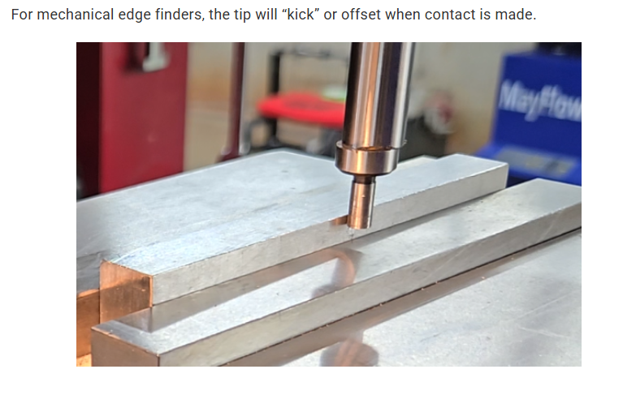

Step 1: Mount the Edge Finder
- Insert the shank of the edge finder into the machine spindle or collet.
- Ensure it is seated securely and runs true.
- The 6mm tip should be clean and not damaged.

Step 2: Start the Spindle at Low RPM
- Turn on the spindle and set the speed to 400–750 RPM.
- The edge finder has a spring-loaded tip, which will visibly wobble when spinning.
Important: Don't spin too fast, or the edge finder could fly apart or fail to function properly.

Step 3: Approach the Workpiece Slowly
- Use the machine’s table or handwheels to move the workpiece toward the rotating tip.
- Approach from the X-axis or Y-axis, depending on which edge you want to find.
- Move in small increments (ideally 0.01 mm or less).
As the spinning tip gets close to the edge, it will begin to align itself.

Step 4: Detect the “Snap” or “Jump” (Kicks off)
- Now the tip just contacts the edge of the workpiece:
  - The wobble will stop, and the tip will appear to run concentrically.
  - If you move just a little more, the tip will snap or jump to the side.
This "snap" moment indicates contact with the workpiece edge.

Step 5: Calculate the Edge Position
- The centre of the spindle is not yet aligned with the workpiece edge.
- The edge you just touched is offset by half the tip’s diameter.
For a 6mm edge finder:
Offset = 6mm ÷ 2 = 3mm

Step 6: PART Zero Offset
- Once the edge finder snaps, stop moving the table.
- Note the reading (or machine coordinate).- Work offsets
- Now, add or subtract the 3mm offset in the direction of approach to determine the true edge position.
Example:
If you're approaching from the +X direction and your DRO says X = 50.00 mm when it snaps:
- True edge = 50.000 mm − 3.000 mm = 47.00 mm
- Set X = 47.00 mm as your X zero (or touch-off point)

Step 7: Repeat for Other Axes (Optional)
- Repeat the same process for the Y-axis if needed.
- Always subtract 3mm (half of the edge finder diameter) to get the actual edge.

